

CANDIDATE BOOKLET

7th October 2024

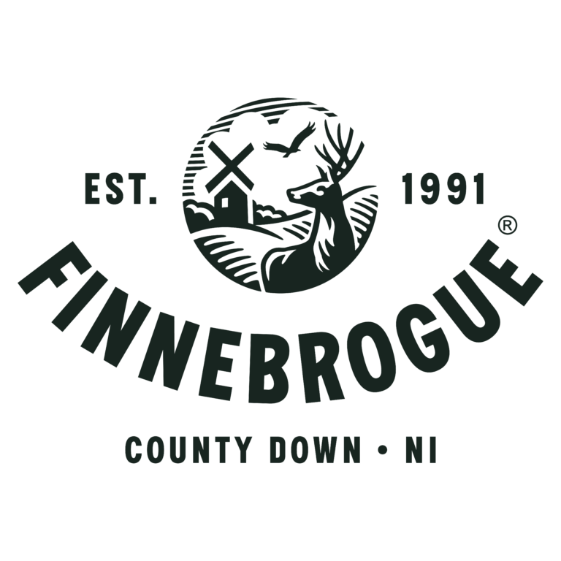

Point of Contact: Steve Morrow Title: Head of Executive Search

Email: [stephen.morrow@stafflinerecruit.com](mailto:stephen.morrow@stafflinerecruit.com) Telephone: 0738 421 8405

# WHO WE ARE

***Our journey so far***

A family-owned business based in Downpatrick, Finnebrogue made its name producing premium sausages for leading supermarkets before launching its revolutionary Naked bacon and ham, made without nitrates; and opening the doors to new state to a new state of the art plant-based factory in 2020. Finnebrogue is now one of the UK’s leading and award-winning food producers with over 1200 employees.

***The story of one man’s vision to change the world***

A story that can be traced back to 1991. A family farm built into the business it is today. We just love this place. It’s the land where we first bred a herd of deer/ Where we built a business with a handpicked team that has grown into a community of over one thousand loyal people.

***Our people are our lifeblood***

Our ethos is based upon a belief that people are the lifeblood of our business – and our people strategy focuses on employees enjoying what they do.

***Like the Seasons, our purposeful change continues***

To do better for and with this beautiful land that shapes our ideas. We make food the best it can be, without being bound by the way it has always been done. We are more than just sausage and bacon makers, deer and wagyu farmers, plant-based producers. We are humble foodies on a mission to do better, to make tasting food for the people who share our restless pursuit of perfection.

We look at what is wrong with food to figure out how to make it the best it can be, without being bound by the way it has always been done. This kind of innovative thinking has led Finnebrogue to multiple awards, nationwide acclaim and has established us as a leading food producer. In 2024, we were recognised as the UK’s Employer of the Year by Grocer Gold and the Best Place to Work in Northern Ireland by the Irish News Workplace & Employment Awards. Our robust People Strategy offers career pathways and development opportunities for all employees, emphasising talent growth and wellbeing with generous benefits for all. We are proud to be the first food producer in the UK and Ireland to achieve the Diversity Mark accreditation and are committed to fostering an inclusive and supportive workplace. With four sites in Downpatrick, County Down, our business continues to grow rapidly, with turnover growing from £50M to £200M in the past 6 years. Join us at Finnebrogue, where innovation meets excellence, and every team member is valued and empowered to grow.

# JOB

DESCRIPTION

***Summary of Job*** The Engineering Manager will be responsible for all equipment, processes, and controls within the DBP facility. As the Engineering Manager, you will support your Team and Production colleagues in ensuring down time is minimised through preventative action and prioritising break downs. You will advise on technical issues, resolve, and share best practice to reduce a recurrence. Working in collaboration with the Engineering Support team and Production colleagues, you will strive to continually improve the Engineering Maintenance team. A requirement of the role will be to manage annual budgets and to ensure that all Engineering spend is within current guidelines.

***What we would love you to do***

* **Financial**

Ensure that all Engineering spend is within current guidelines and managed within budget.

* **Direct Reports / responsibilities**

All DBP site Maintenance Engineers’

Ability to build, mentor, motivate and lead the Engineering team through technological and cultural change.

Manage & Lead the DBP Site’s Engineering & Maintenance works within the production processing & ancillary equipment, to include fault finding, diagnostic analysis and implement continuous improvement to minimize down time.

Support the Engineering team with Processing equipment works, prioritising Engineering resource as appropriate.

Co-ordinate the Planned Preventative Maintenance works on all processing plant and machinery, using the integrated CMMS system.

Full, accurate and timely completion of all maintenance logs, schedules, etc. to comply with current Health and Safety legislation, Company Insurance requirements and Food Safety & Quality regulations.

Develop & review maintenance schedules, especially for new & upgraded equipment and integrate these within the existing PPM schedule.

Co-ordinate & liaise with Contractors and Equipment Suppliers on Project work and Equipment upgrades.

Develop and maintain a positive Team working relationship with Production.

Assess the Training & development of the Engineering team.

Lead the Reliability & Maintenance initiative focused on Preventative & Predictive maintenance, with a significant reduction on Reactive work.

This description is intended to be a guide of what duties are most likely but should not be taken as a definitive list. Finnebrogue reserves the right to vary duties and add duties as they see necessary.

# PERSON

SPECIFICATION

***What you will bring***

* Strong sense of purpose and committed to making a positive impact.
* Pro-active in seeking solutions and implementing them promptly, ensuring all health and safety requirements are considered.
* A team player attitude and ability to work with other colleagues.
* An organised approach to prioritising work and good communication skills to be able to provide information and updates to the Head of Engineering and other business stakeholders.

**Skills and abilities**

* Well-organised with the ability to work independently and as part of a wider team.
* Strong Planning & Administration skills
* Good communication and inter-personal skills including written and verbal.
* Ability to take the initiative and use problem solving skills to seek solutions.

**Your experience and qualifications**

* Level 3 qualification in Engineering
* Minimum 10 years’ experience in a similar role within a fast-paced manufacturing environment.
* Familiar with modern maintenance and manufacturing methodologies.
* Robust and flexible approach
* Health and Safety / First Aid related qualification
* Experience within the Food processing sector.
* Competent in the use of Microsoft Office
* Apprenticeship trained.
* Experience working on electro-mechanical, pneumatic, and PLC controlled equipment.

# BENEFITS PACKAGE

**Key Benefits**

Competitive Salary - Negotiable

Bonus Scheme

Company Pension Scheme

Free on-site parking

30 Days annual leave (including Bank Holidays)

Length of Service – additional leave days

**Other Benefits**

Subsidised canteen, free breakfast & lunch options

Cycle-to-work scheme

Electric Car Scheme

Subsidised Gym membership

Confidential Counselling Services

Health & Wellbeing calendar of events

Social Clubs / Golf Society

Family Fun Days

# Location

Down Business Park, 46 Belfast Road, Downpatrick, BT30 9UP

# Selection Process

A shortlist of candidates for interviews will be prepared based on the information contained in the CV received. It is important that all applicants demonstrate how, and the extent to which, they satisfy each of the Eligibility, Essential & Desirable criteria specified.

Only those candidates who meet the Eligibility Criteria will proceed to the formal short- listing process. Where large numbers of candidates meet the Essential Criteria and Desirable Criteria then other short-listing techniques may be used to further shortlist candidates.

## Interview

Those candidates called for interview will be questioned on the areas covered in the job specification. Candidates will be asked to provide specific examples to illustrate their competence in each of the areas.

Interviews will be held at the Finnebrogue, Down Business Park, 46 Belfast Road, Downpatrick, BT30 9UP

**Interview Panel**

Gerry Maguire - Head of Engineering

Chris Overend - Human Resource Manager

**Terms and Conditions**

The appointee will become an employee of Finnebrogue.

The successful candidate will be expected to work 37.5 hours per week